**Data Ingestion:**

**Data Preprocessing: -**

Removing null values:-

Removing duplicates: -

Data encoding:-

* 1. **Key Performance Indicators (KPIs)**

To gain insights into various aspects of e-commerce performance, the following KPIs were computed:

**Total Sales (Net Amount) by Product Category and Location:**

* **Purpose:** The purpose of calculating Total Sales (Net Amount) by Product Category and Location is to evaluate the revenue generated by different product categories across various geographical locations.
* **Insight:** This KPI provides insights into which product categories are driving the most sales in particular locations, uncovering regional preferences and trends.



**Average Order Value (AOV)**

The average amount spent per transaction, calculated as total sales divided by the number of transactions.

* + - **Purpose**: Helps gauge customer spending patterns and purchasing behavior.
    - **Insight**: A high AOV can imply successful upselling or cross-selling strategies, while a lower AOV may indicate room to encourage larger purchases.

**Sales by Product Category**

Total sales segmented by each product category.

* + - **Purpose**: Identifies the most and least popular product categories, helping optimize product range and marketing focus.
    - **Insight**: High sales in specific categories highlight customer preferences and allow for resource allocation towards high-demand products.

**Sales by Gender**

Total sales segmented by gender of the customers.

* + - **Purpose**: Provides insight into demographic-based purchasing trends.
    - **Insight**: Sales data by gender helps tailor marketing efforts and product offerings to specific demographics.

**Sales by Age Group**

Total sales segmented by customer age groups.

* + - **Purpose**: Helps understand age-specific trends and preferences, guiding targeted marketing.
    - **Insight**: Identifying age groups with higher purchasing volumes can refine marketing strategies and product offerings.

**Average Discount Amount**

The average discount value per discounted transaction.

* + - **Purpose**: Measures the effectiveness and impact of discounts on buying behaviour.
    - **Insight**: Higher average discounts may drive sales but could impact profitability, while lower discounts might indicate controlled promotional expenses.

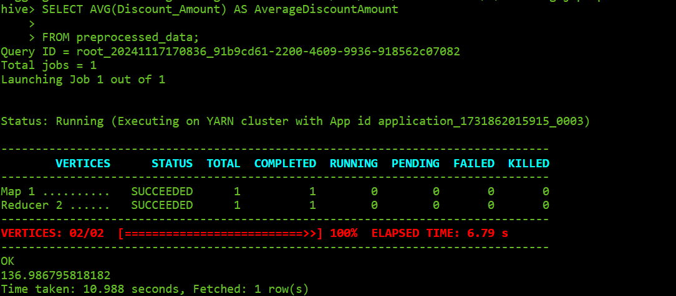

**Sales by Location**

Total sales segmented by geographical location.

* + - **Purpose**: Identifies high-performing regions, aiding in geographical-specific marketing and resource allocation.
    - **Insight**: Sales by location help focus marketing efforts on high-performing areas and identify underperforming regions needing targeted campaigns.

**Top Selling Products**

Products that generate the highest sales within a specified time.

* + - **Purpose**: Helps identify popular products and optimize stock or marketing efforts.
    - **Insight**: Understanding top-selling products informs inventory management and marketing focus, ensuring high-demand products are well-stocked and promoted.

**Sales by Purchase Method**

Total sales segmented by method of purchase (e.g., online, in-store).

* + - **Purpose**: Identifies customer preferences for purchasing channels.
    - **Insight**: Preferred purchase methods inform channel-focused marketing and resource allocation to enhance the customer experience.

These KPIs provide a comprehensive view of a business’s operational and financial health. Regularly tracking and analyzing these metrics helps to drive informed decision-making, optimize marketing efforts, manage inventory effectively, and improve customer experience